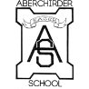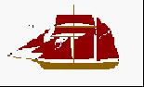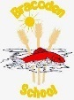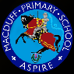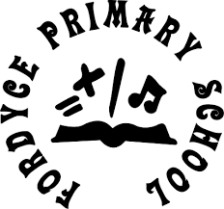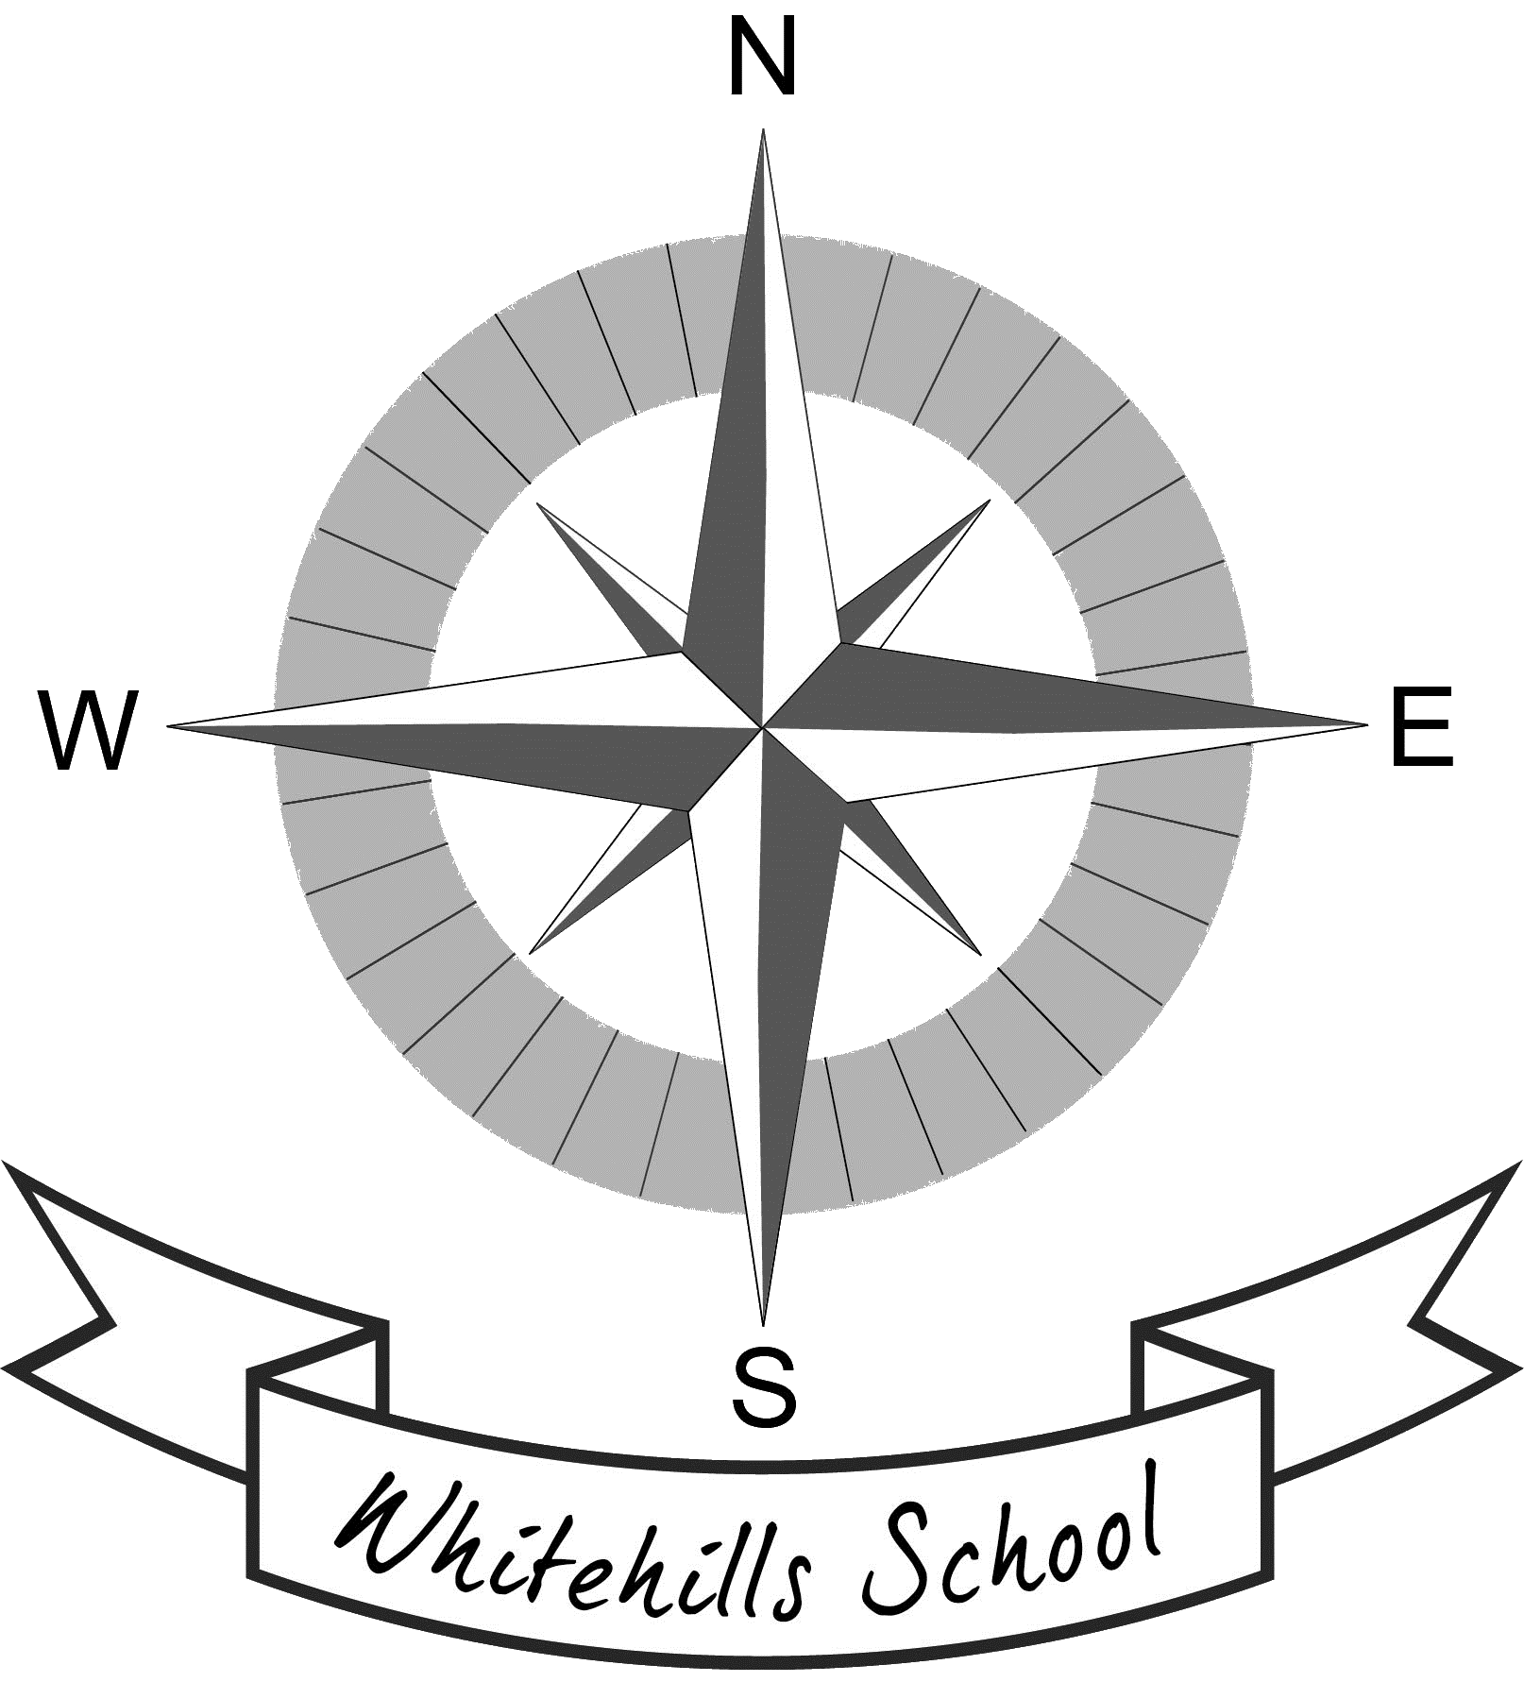

2nd October, 2020
Dear Parents / Carers,

Term 2 October – December 2020 School events/activities

As you will be aware there have had to be many changes to what we do in school, to comply with Covid 19 guidance and risk assessments. As we look forward and plan for Term 2 which is usually filled with seasonal events such as Nativity productions, whole school singing performances or Christmas Fairs and activities such as Christmas parties; it is now apparent that many of these will not be possible or need to take a different format

We have been advised that the restrictions around having parents / visitors to the school will remain for the foreseeable future and so there will be no performances in primary schools across the Banff Academy cluster. This also covers parents evenings and open afternoons.

To continue to comply with both the reducing contacts and the no indoor physical activity measures, parties will be held as classes rather than year or level groups. There will be no physical activities such as dancing and will be different to previous years. There will be no food available during these parties but instead each child will receive a goody bag / selection box to take home at the end of the day. This will be organised by either the parent council, local community group or the school itself.

More details will follow re dates for this and other arrangements for Term 2.

As always I would like to thank you for your cooperation and understanding during these challenging and different times.

Kind regards

Laura MacKay

Head teacher

